1. Cloud Storage (GCS) for raw customer CSV
2. Local PostgreSQL (on-prem) for product data
3. Public API for sales JSON

Simply upload data to raw bucket in gcp for option 1.

For option 2,

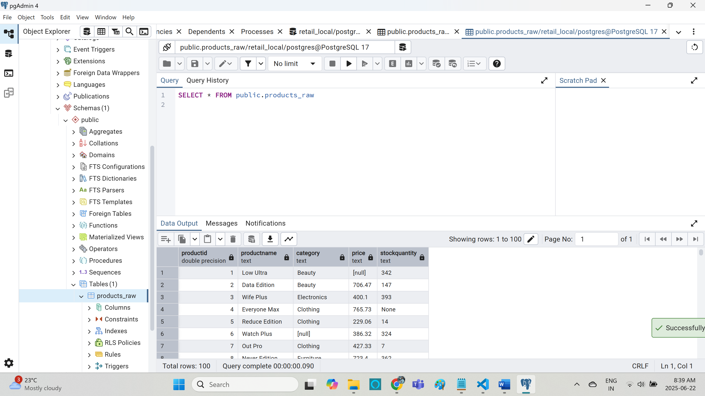

pip install apache-beam[gcp] psycopg2-binary

cleaned and write it to gcs from on-prem

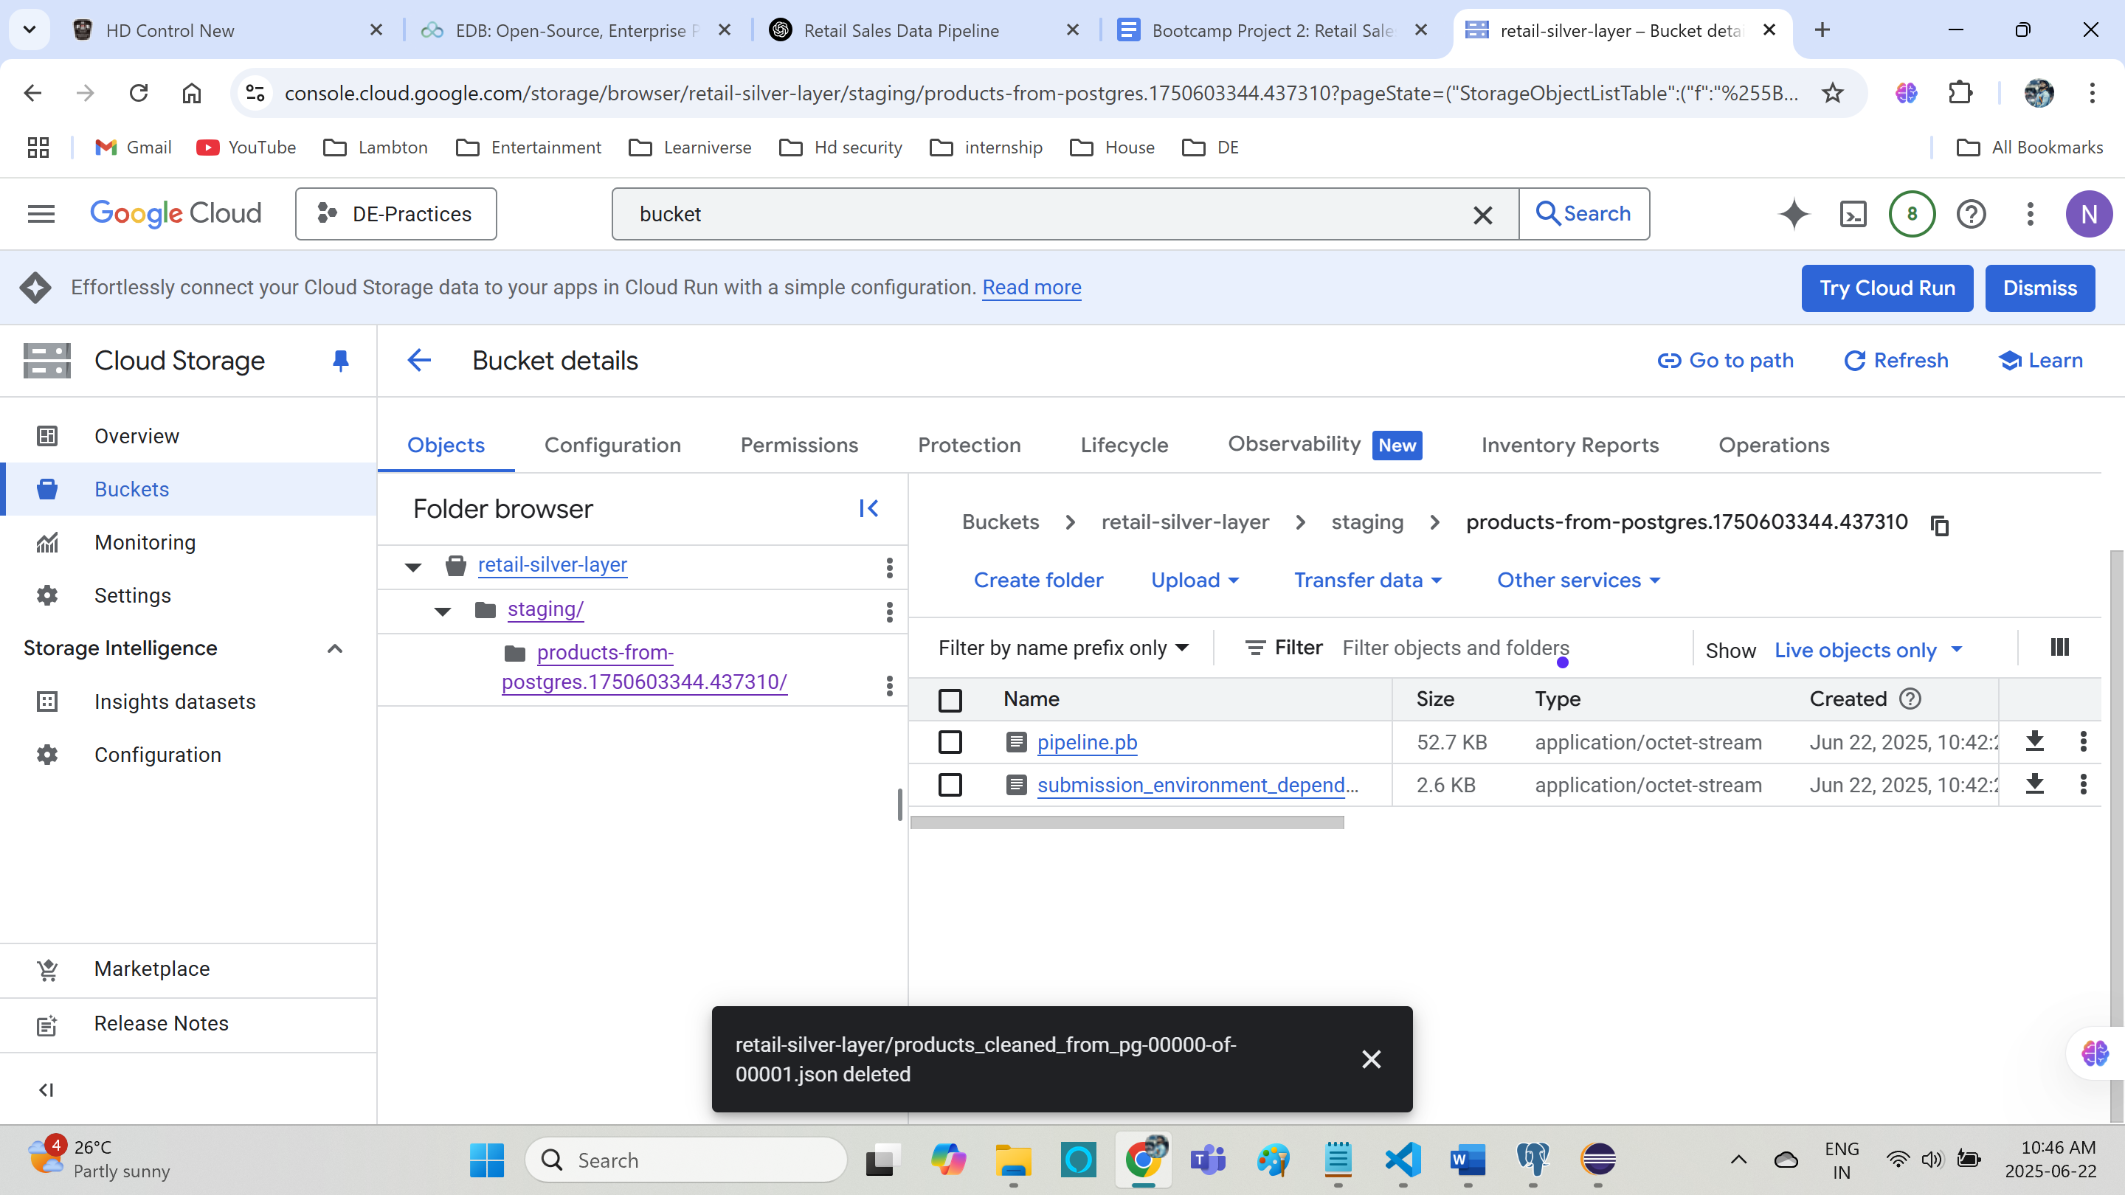

Job created

Running sales data from api:

python transform_sales_api.py

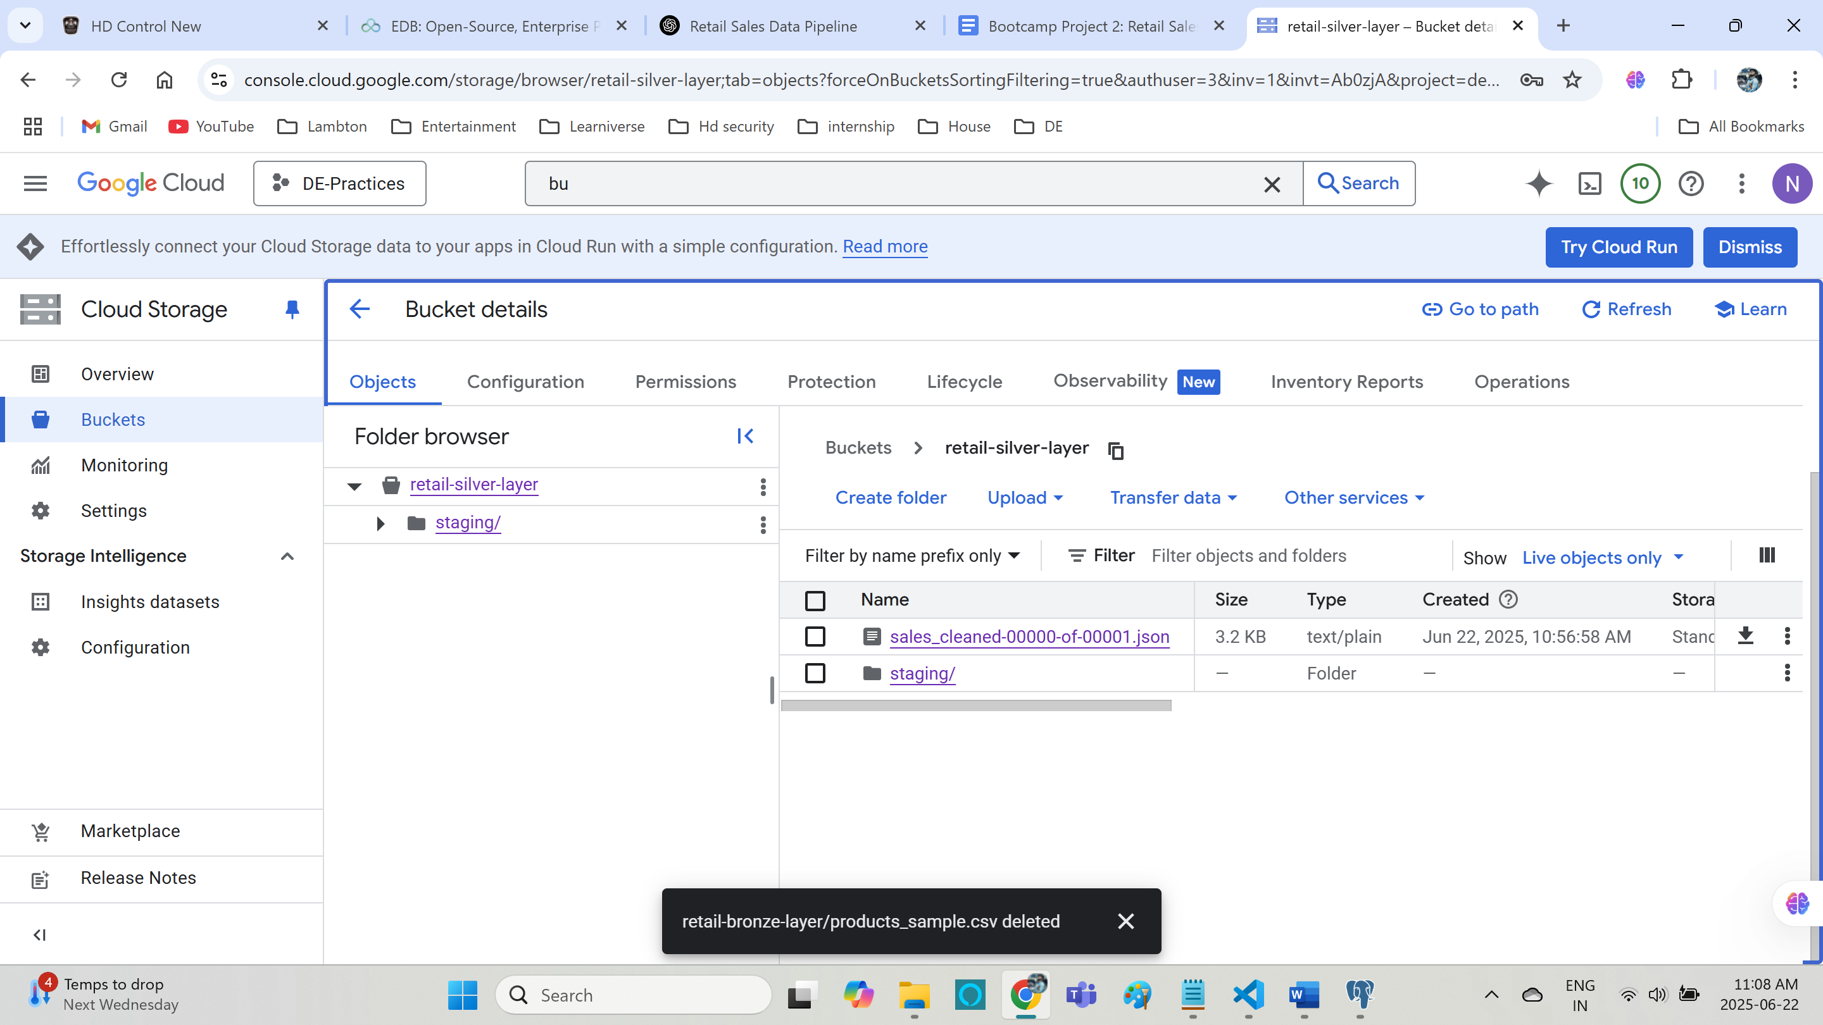

Data from bucket:

1,2,3 done.

